**Online E-commerce System**

|  |  |  |  |  |  |
| --- | --- | --- | --- | --- | --- |
| **Team 13** | | | | | |
| **Team Members** | Meghana  Nanda Kumar | Pratik Karunakar Poojari | Mihr  Makwana | Sai Pravallika Balina | Udaykumar   Shelke |
| **NU and Email ID** | 002645219  nandakumar.me@northeastern.edu | 00264517  poojari.pr@northeastern.edu | 002794479  makwana.mi@northeastern.edu | 002642253  balina.sa@northeastern.edu | 002727131  shelke.u@northeastern.edu |

Cleaning and creating new objects for each table:

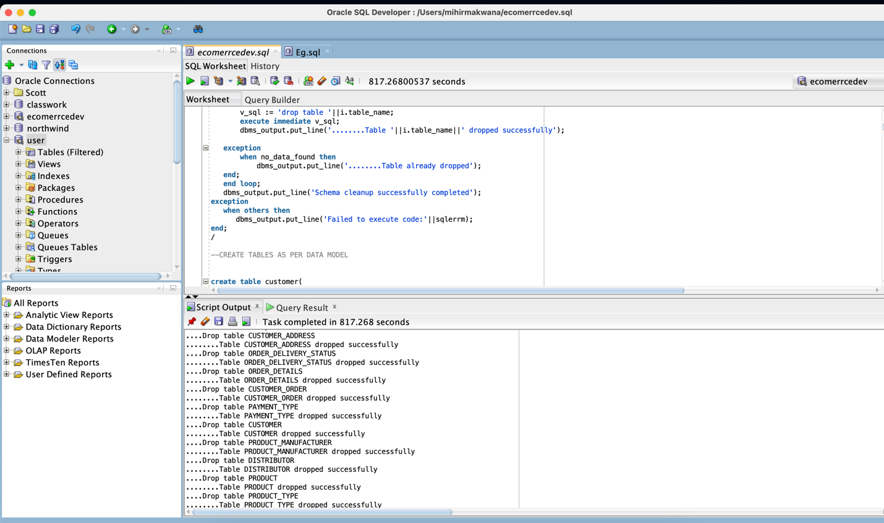

Roles:

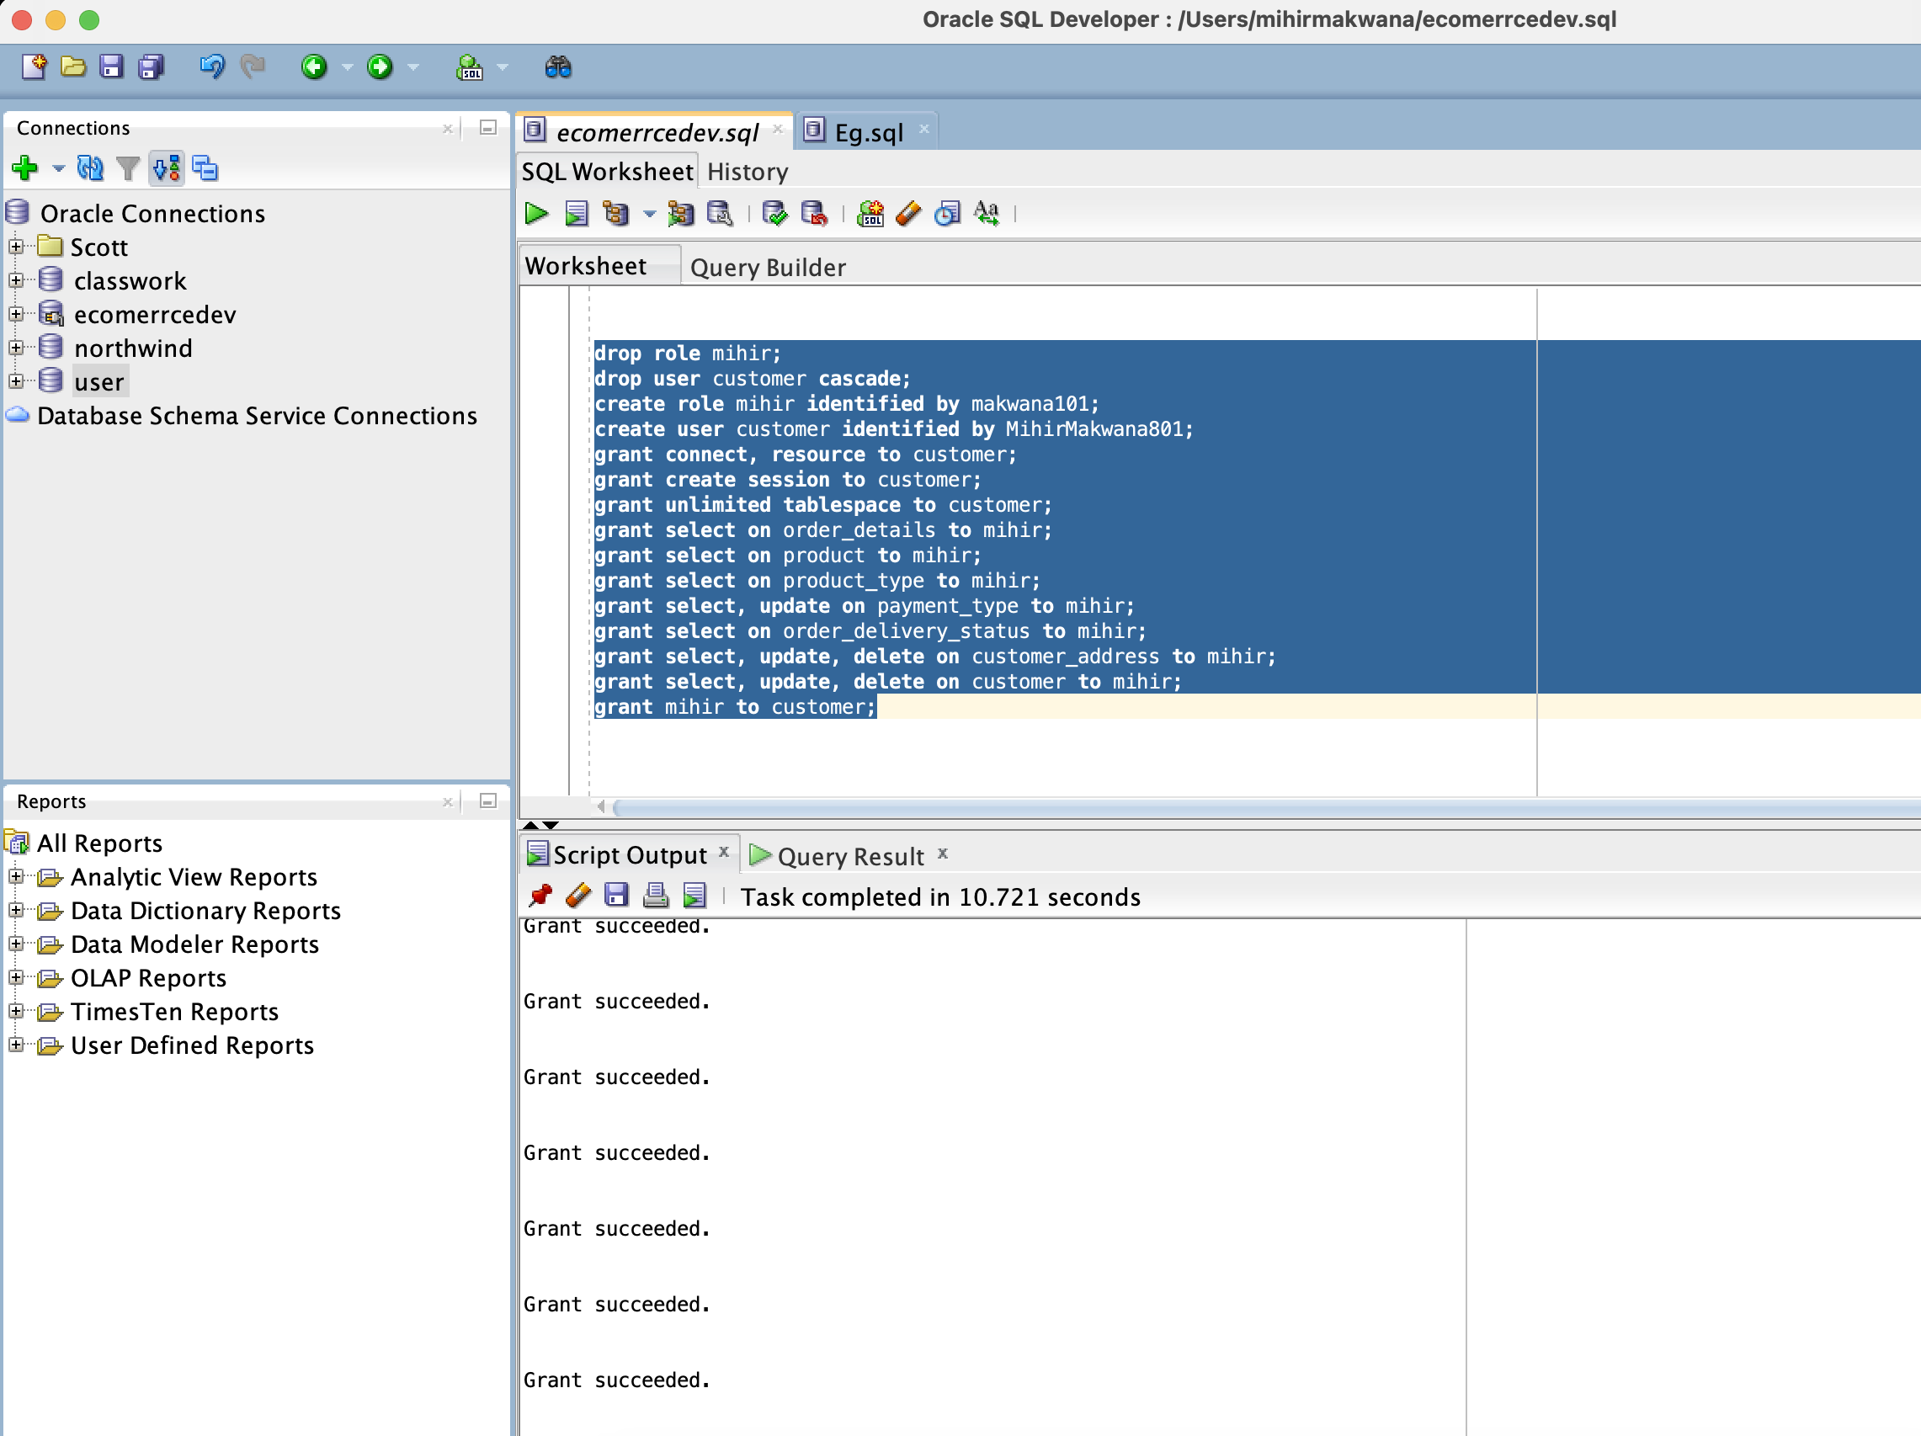

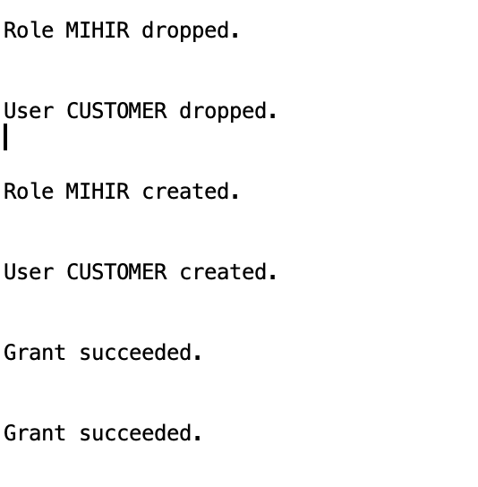

Customer Table:

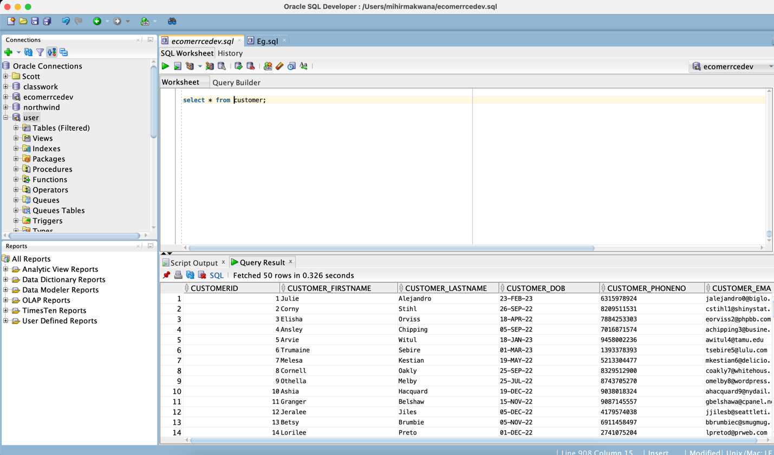

Customer Address Table:

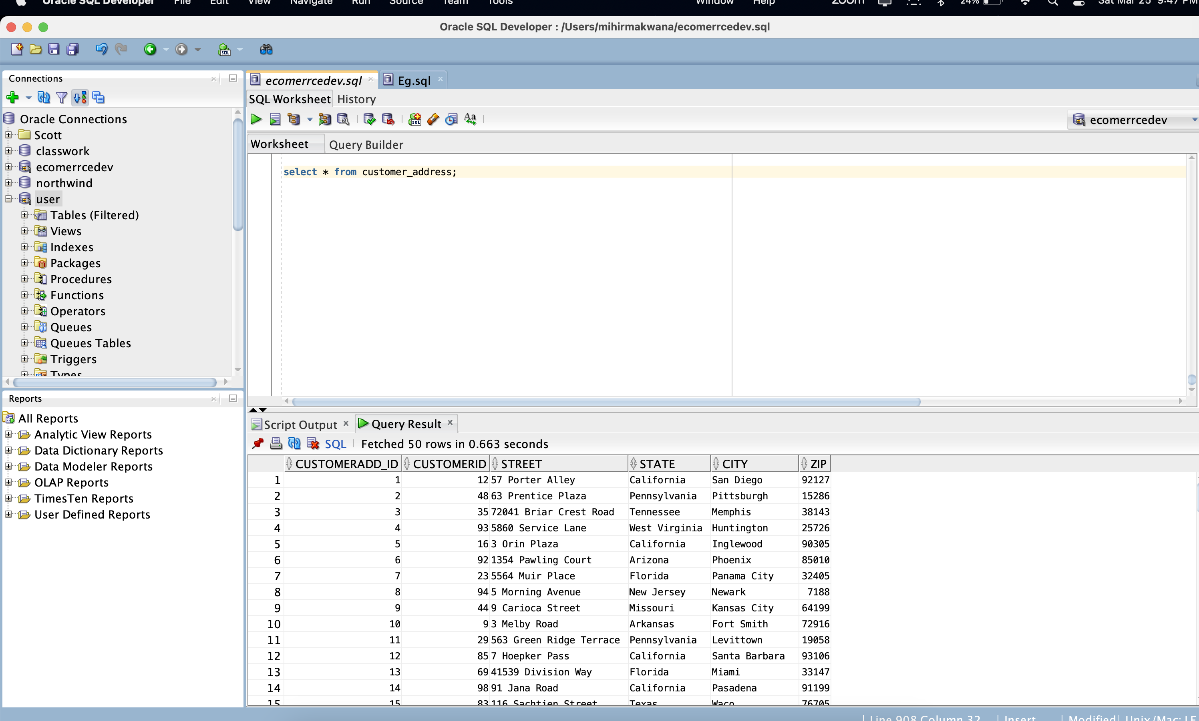

Order Table:

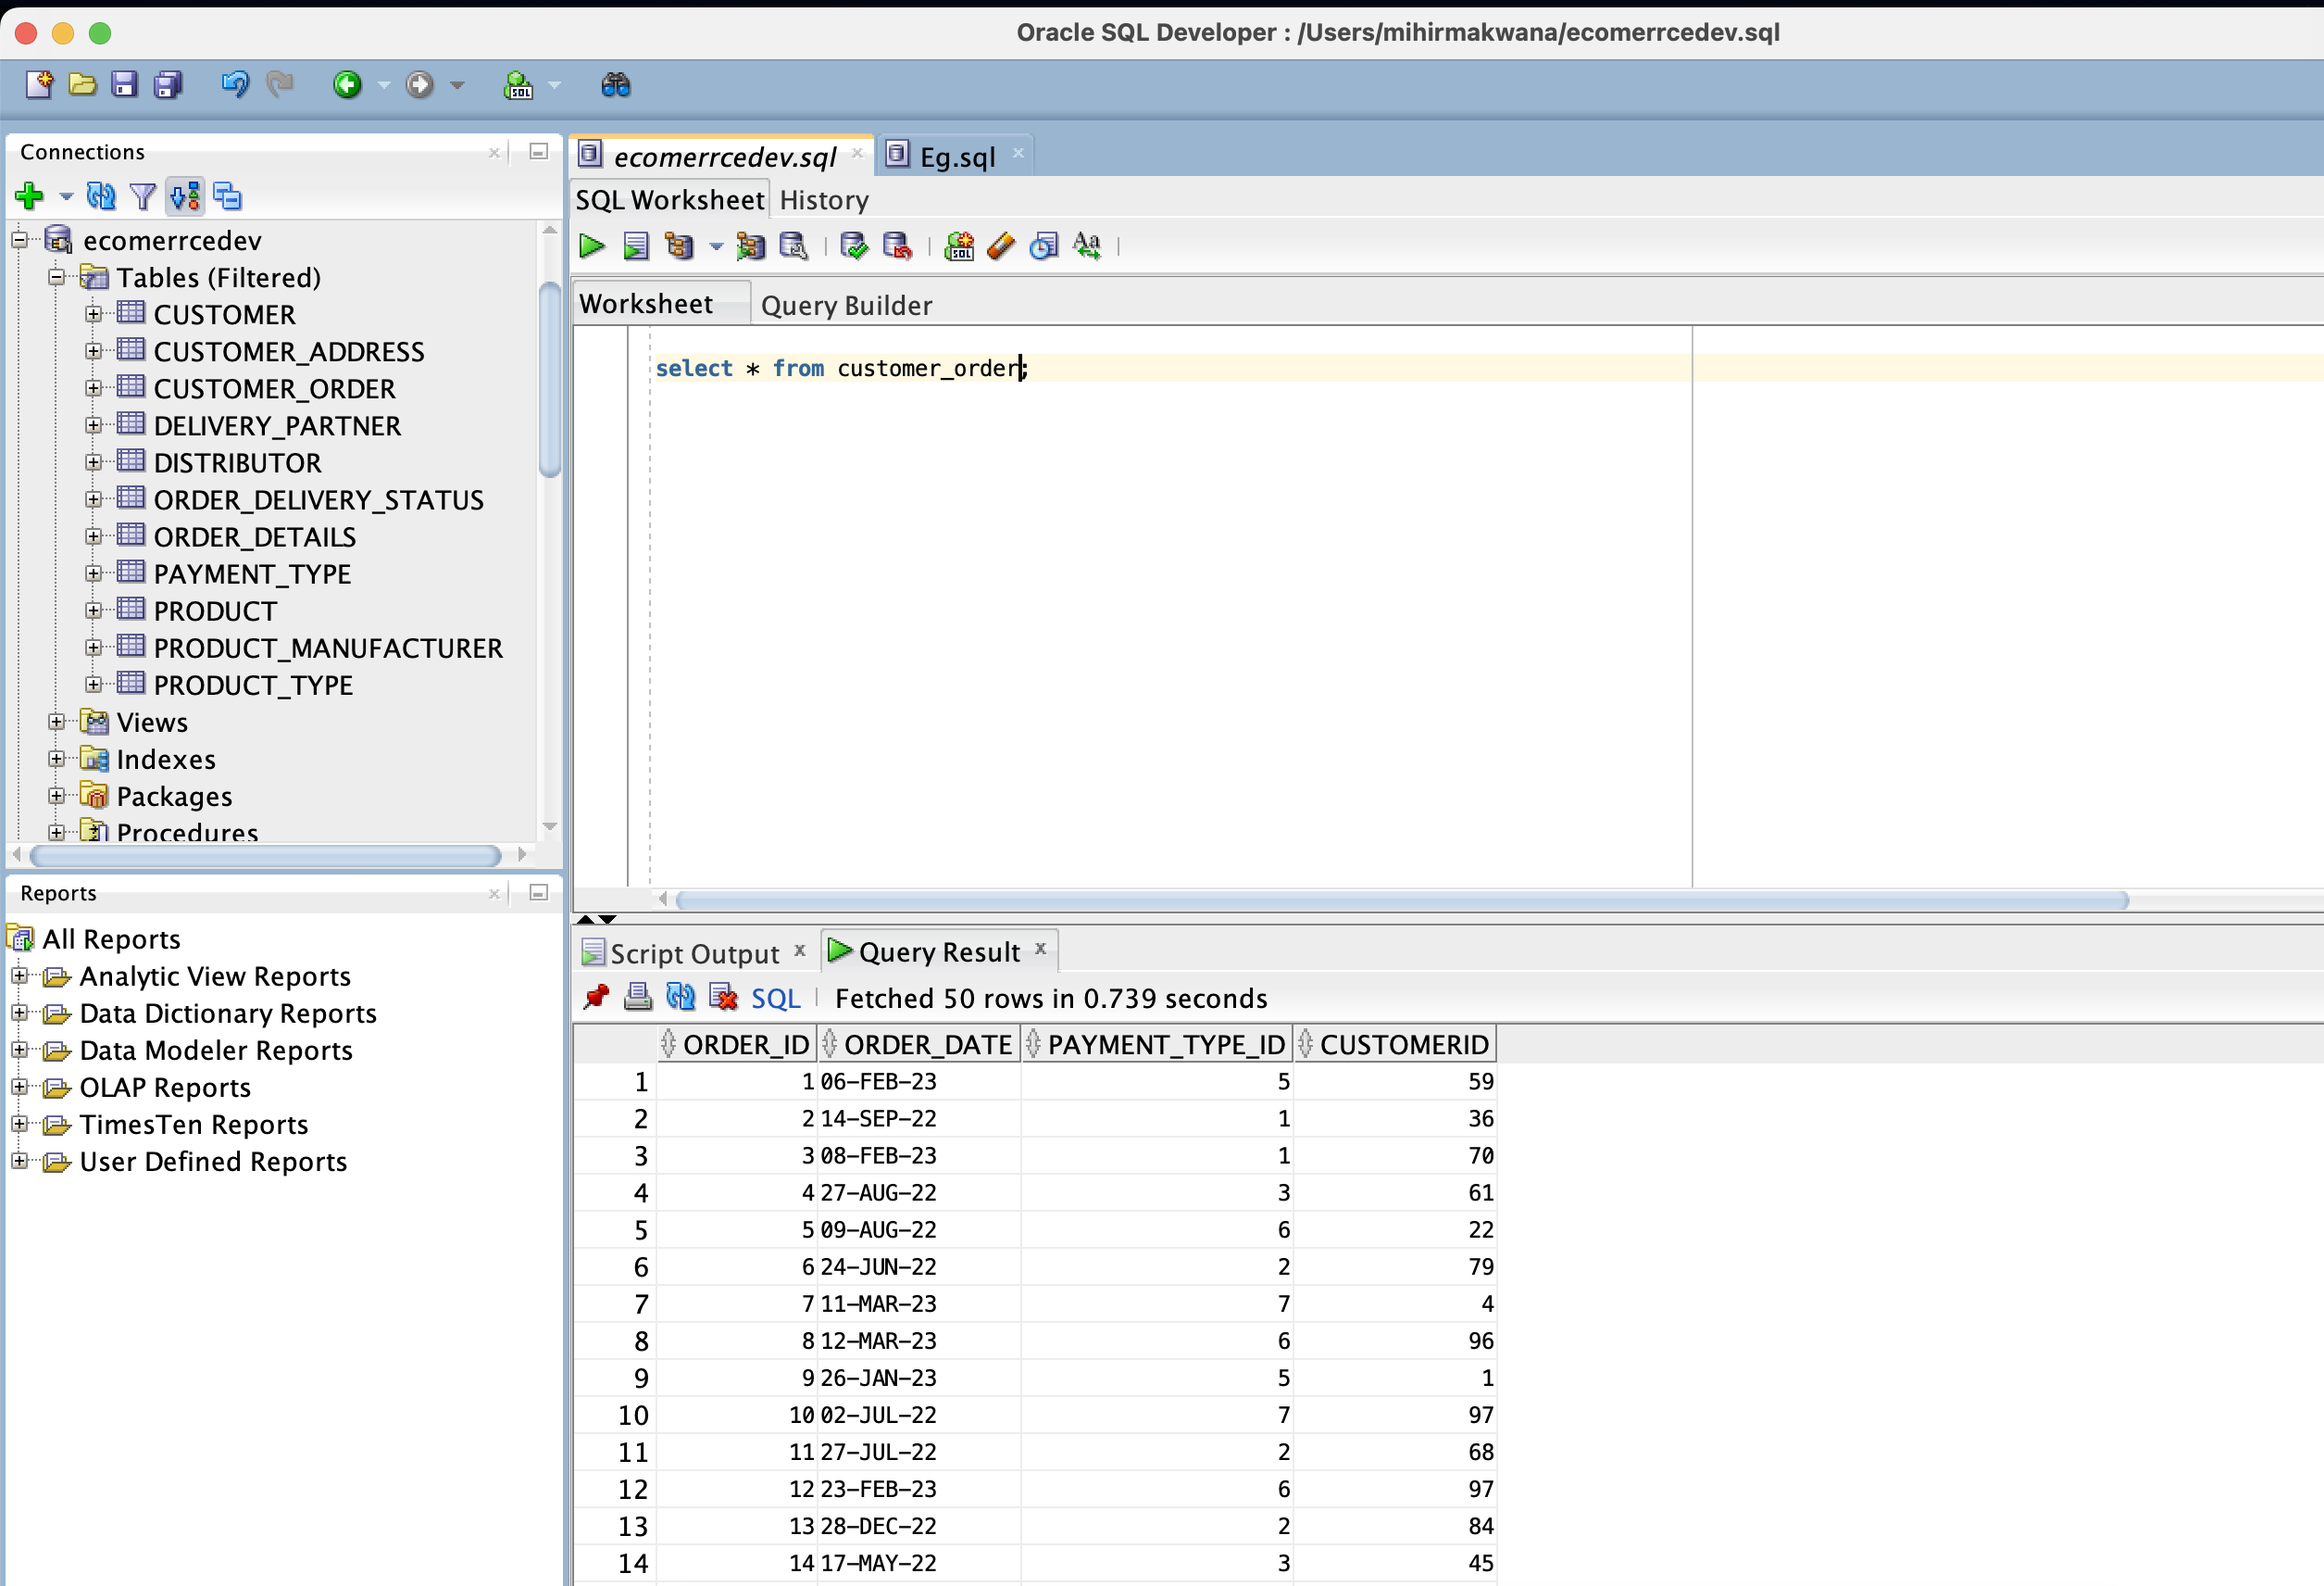

Delivery Partner Table:

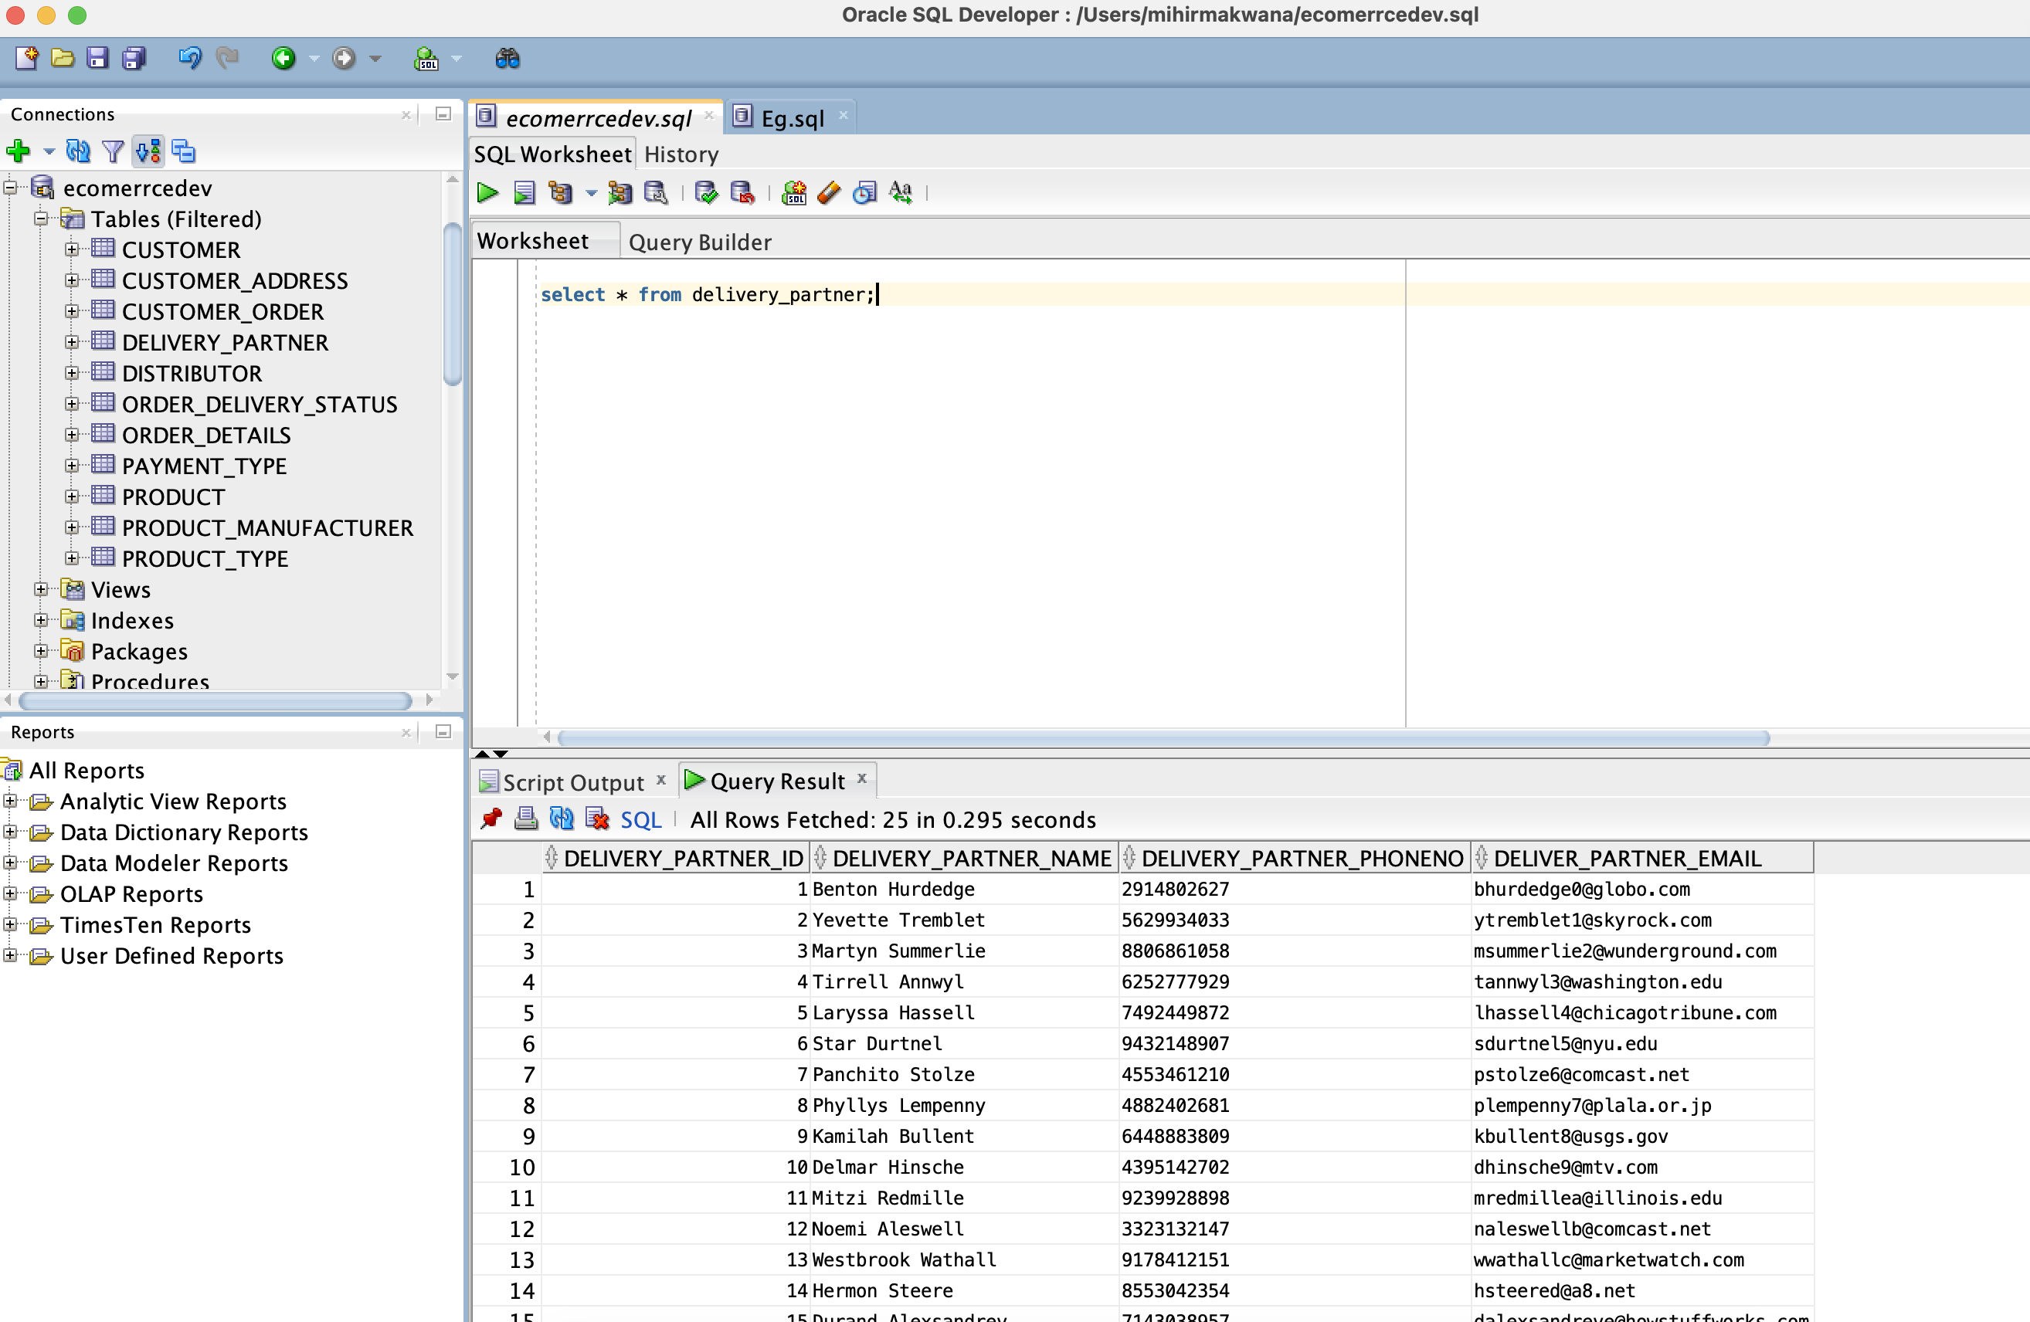

Distributor Table:

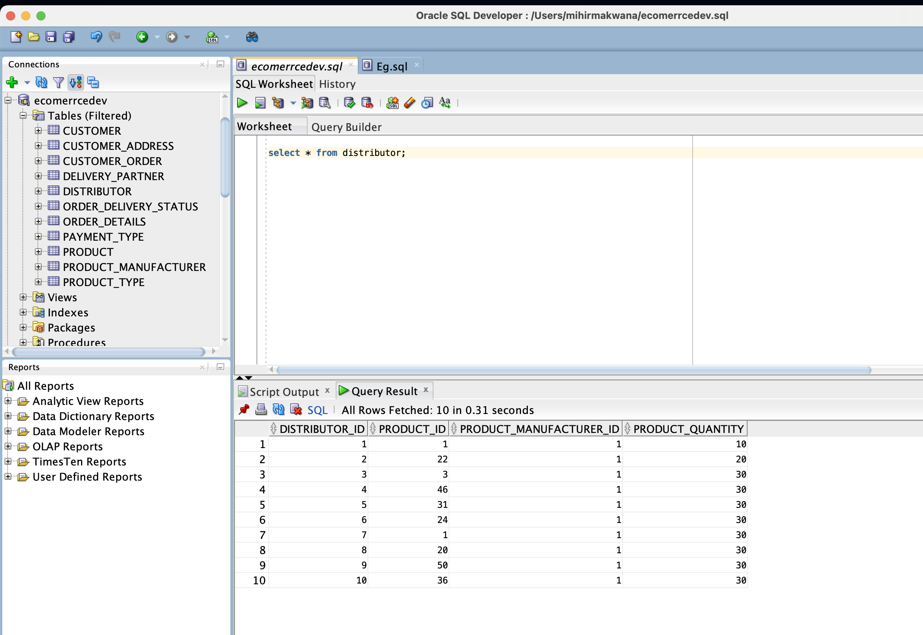

Order Details:

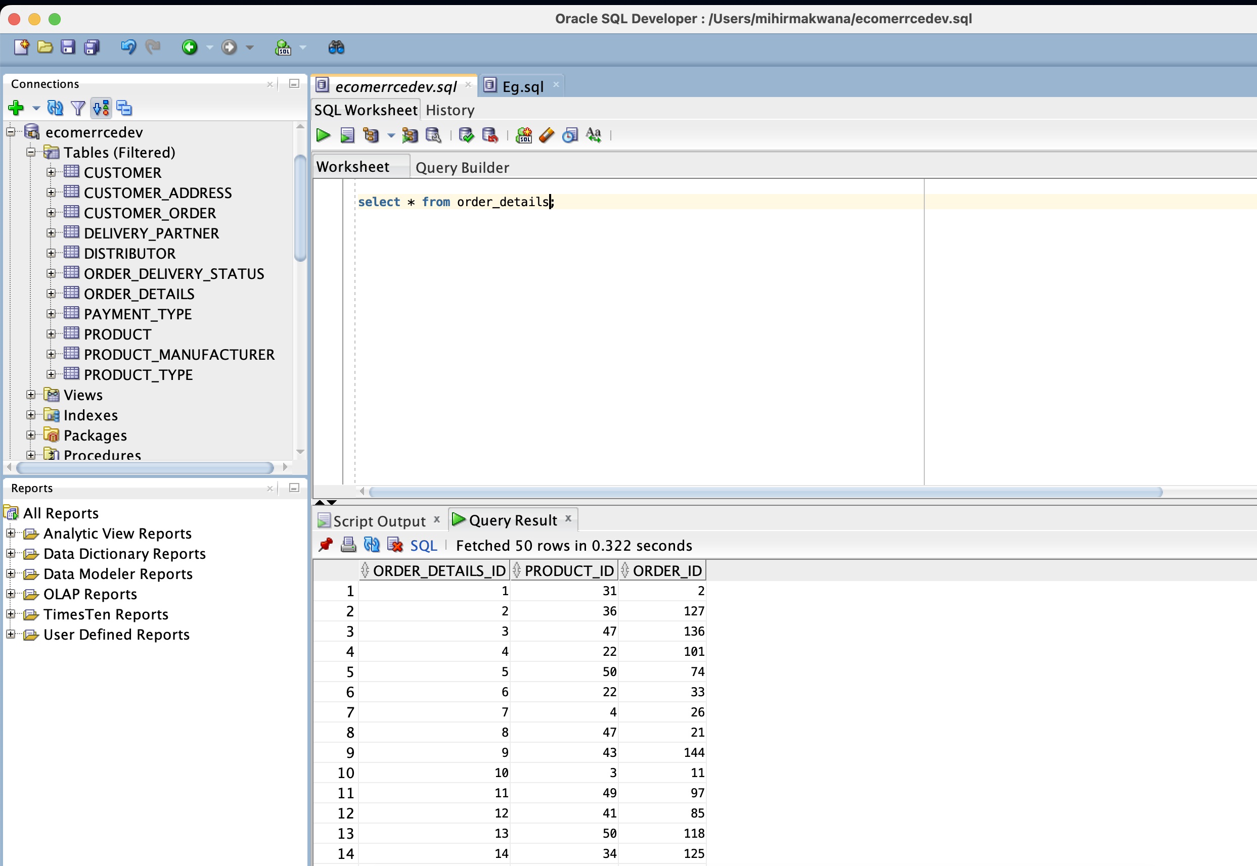

Payment Type:

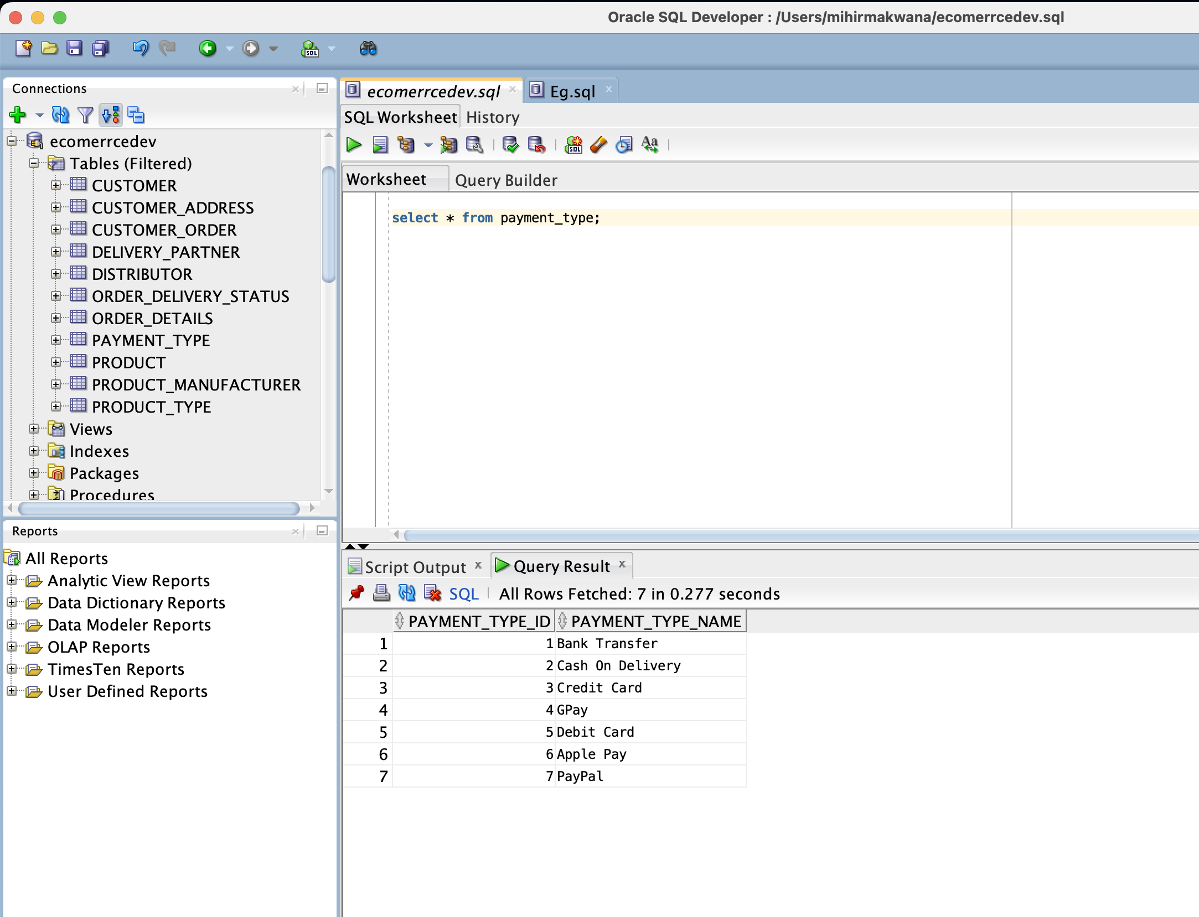

Product:

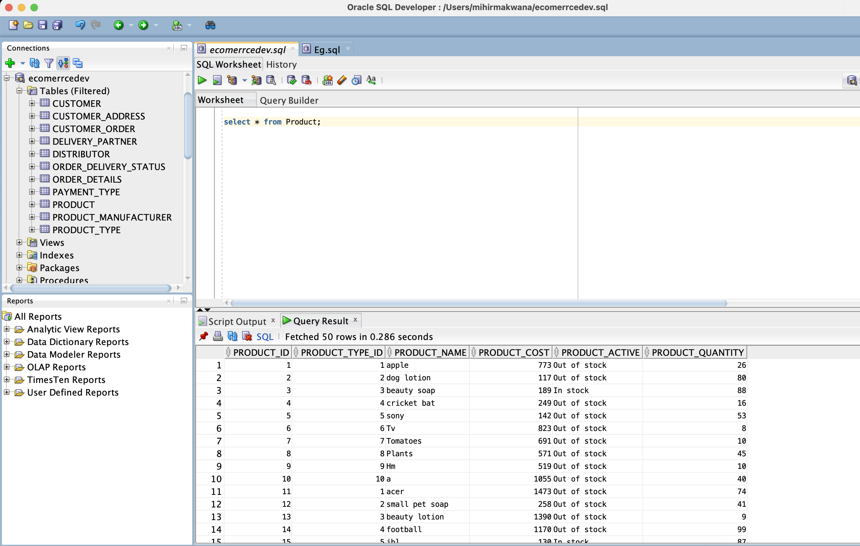

Product Manufacturer: For our database we have only one manufacturer which has many distributors.

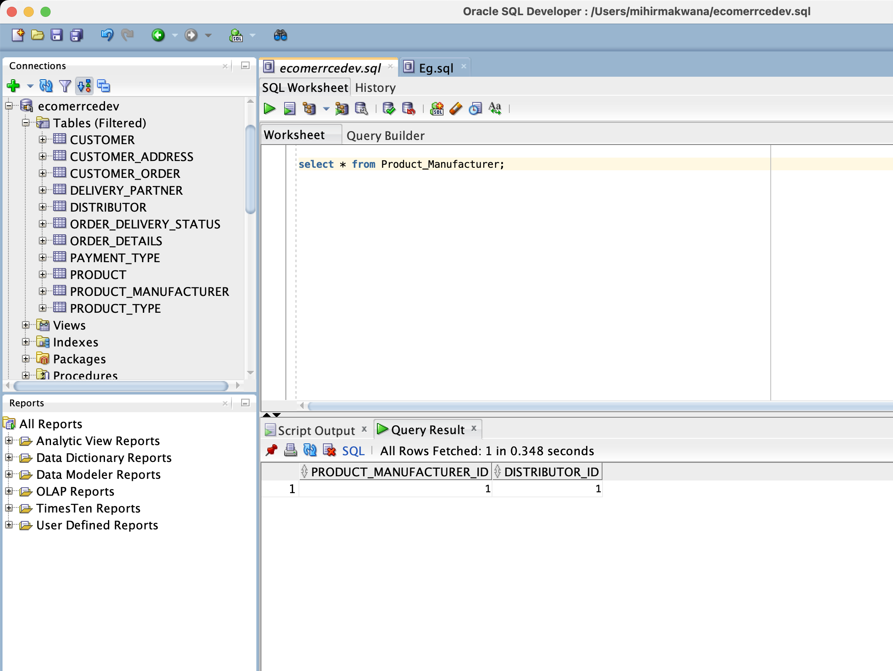

Product Type;

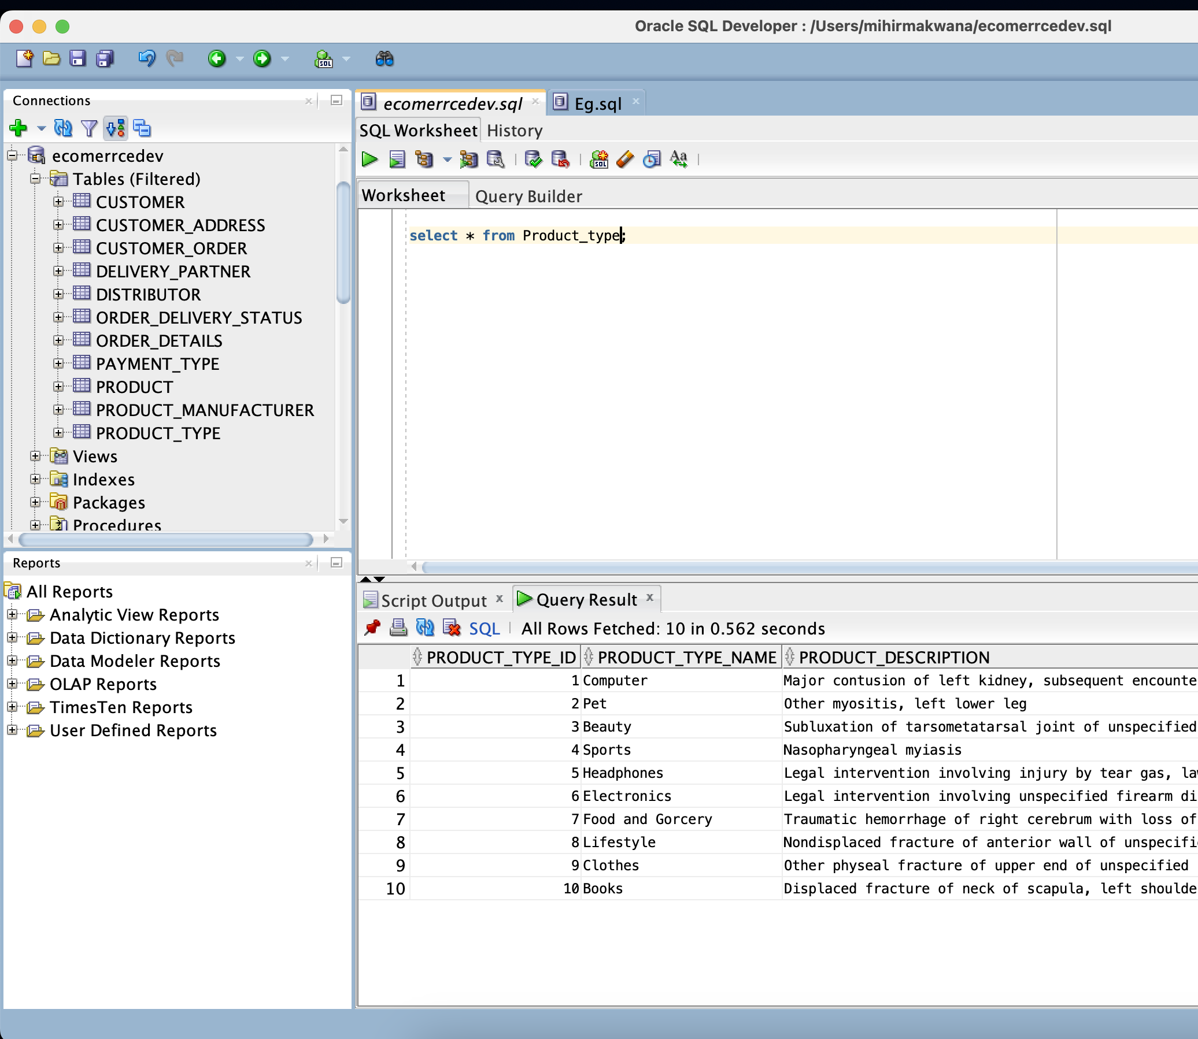

Order Delivery Status:

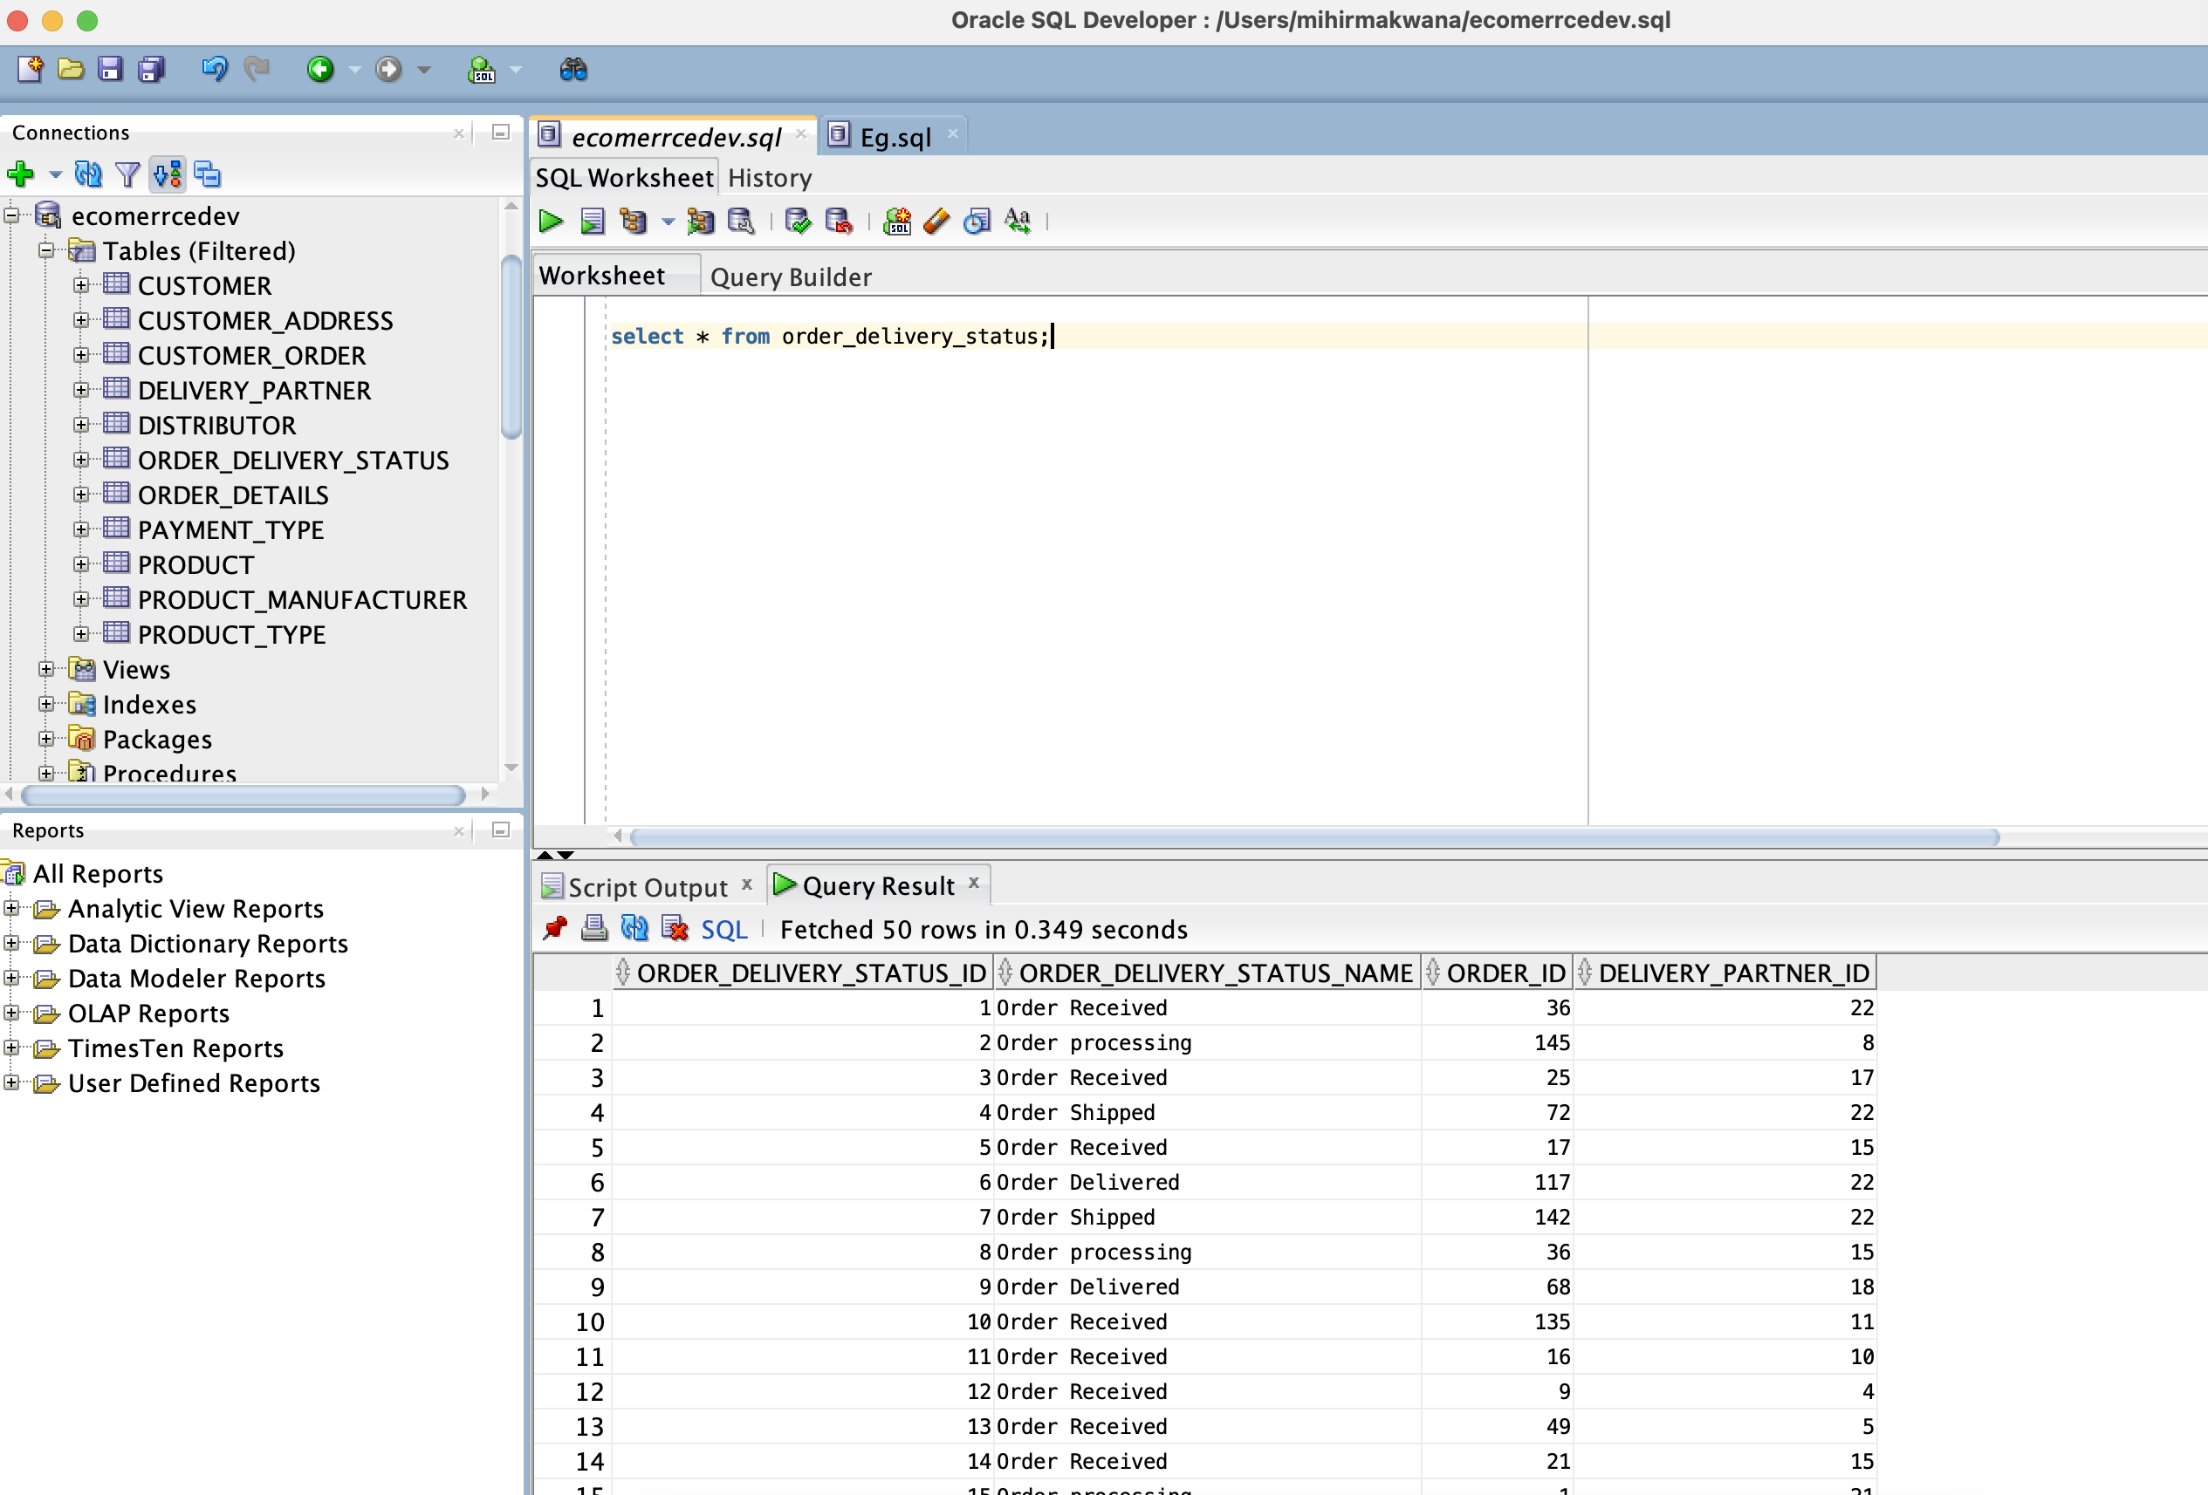

VIEWS:

1. Customer Information:

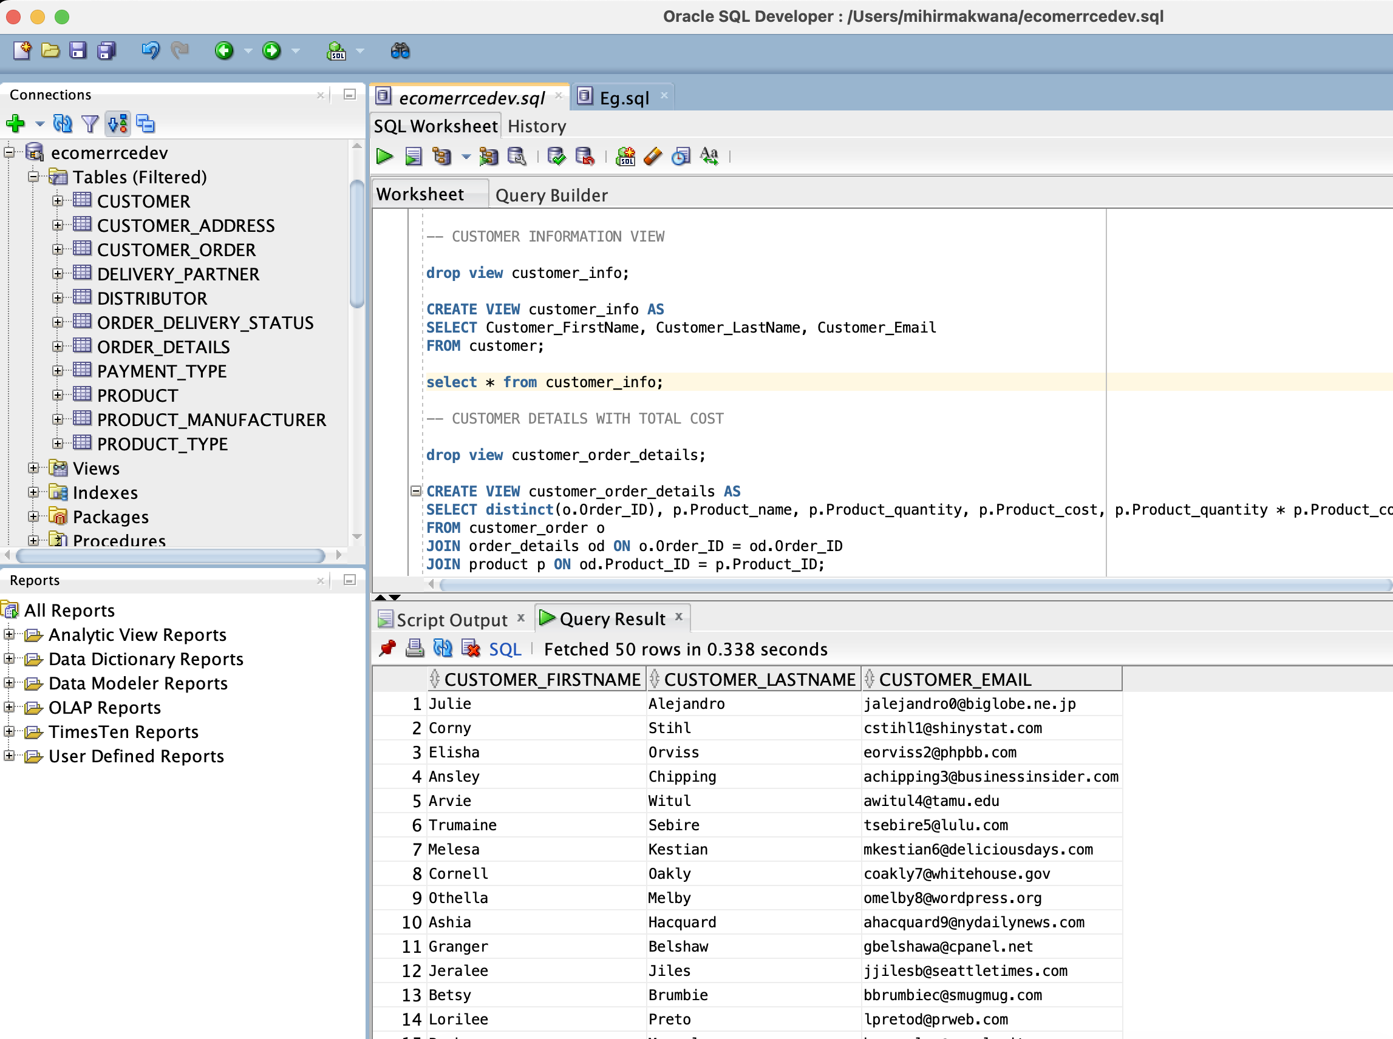

1. CUSTOMER DETAILS WITH TOTAL COST:

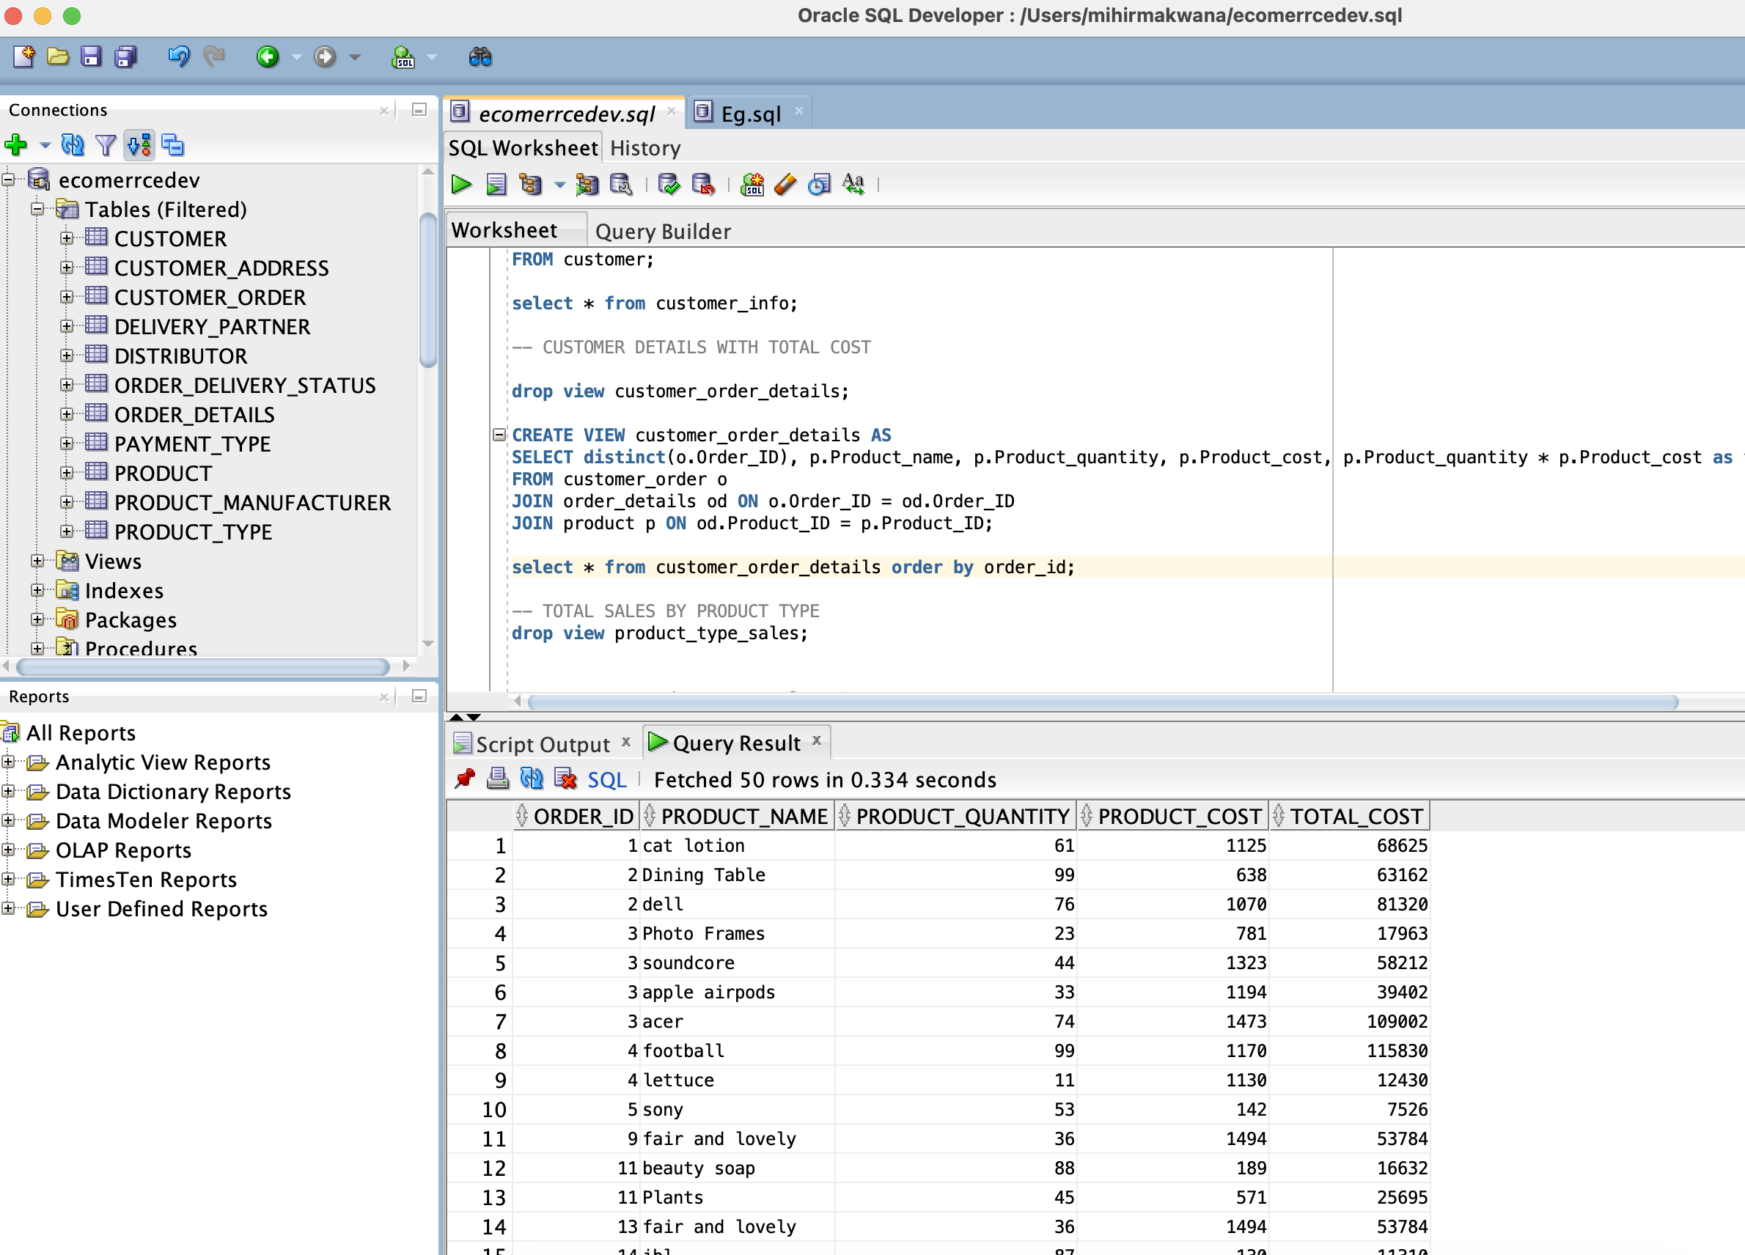

1. TOTAL SALES BY PRODUCT TYPE:

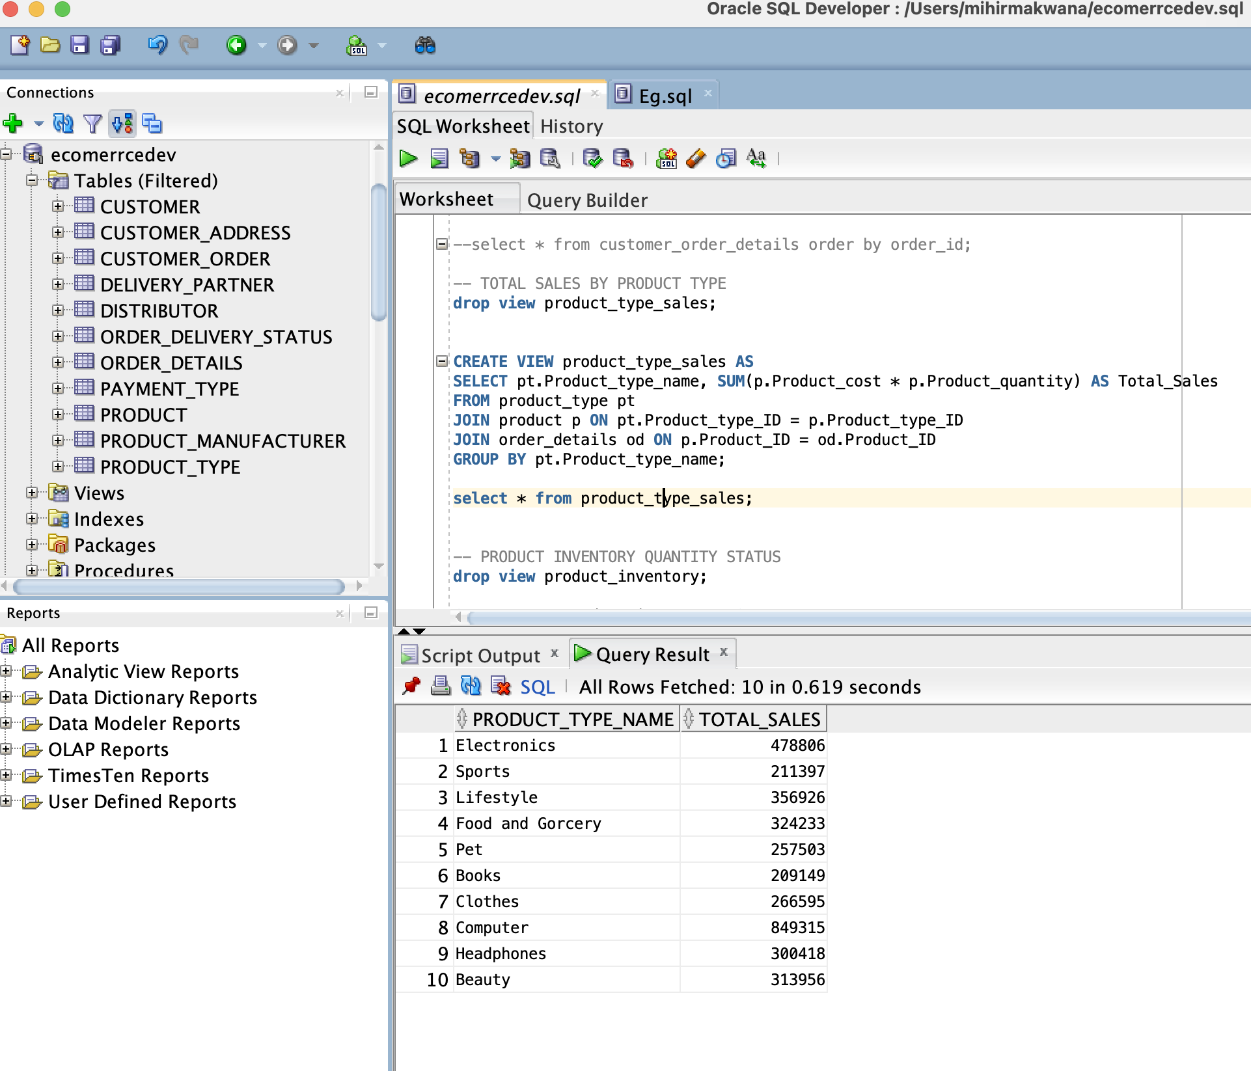

1. PRODUCT INVENTORY QUANTITY STATUS

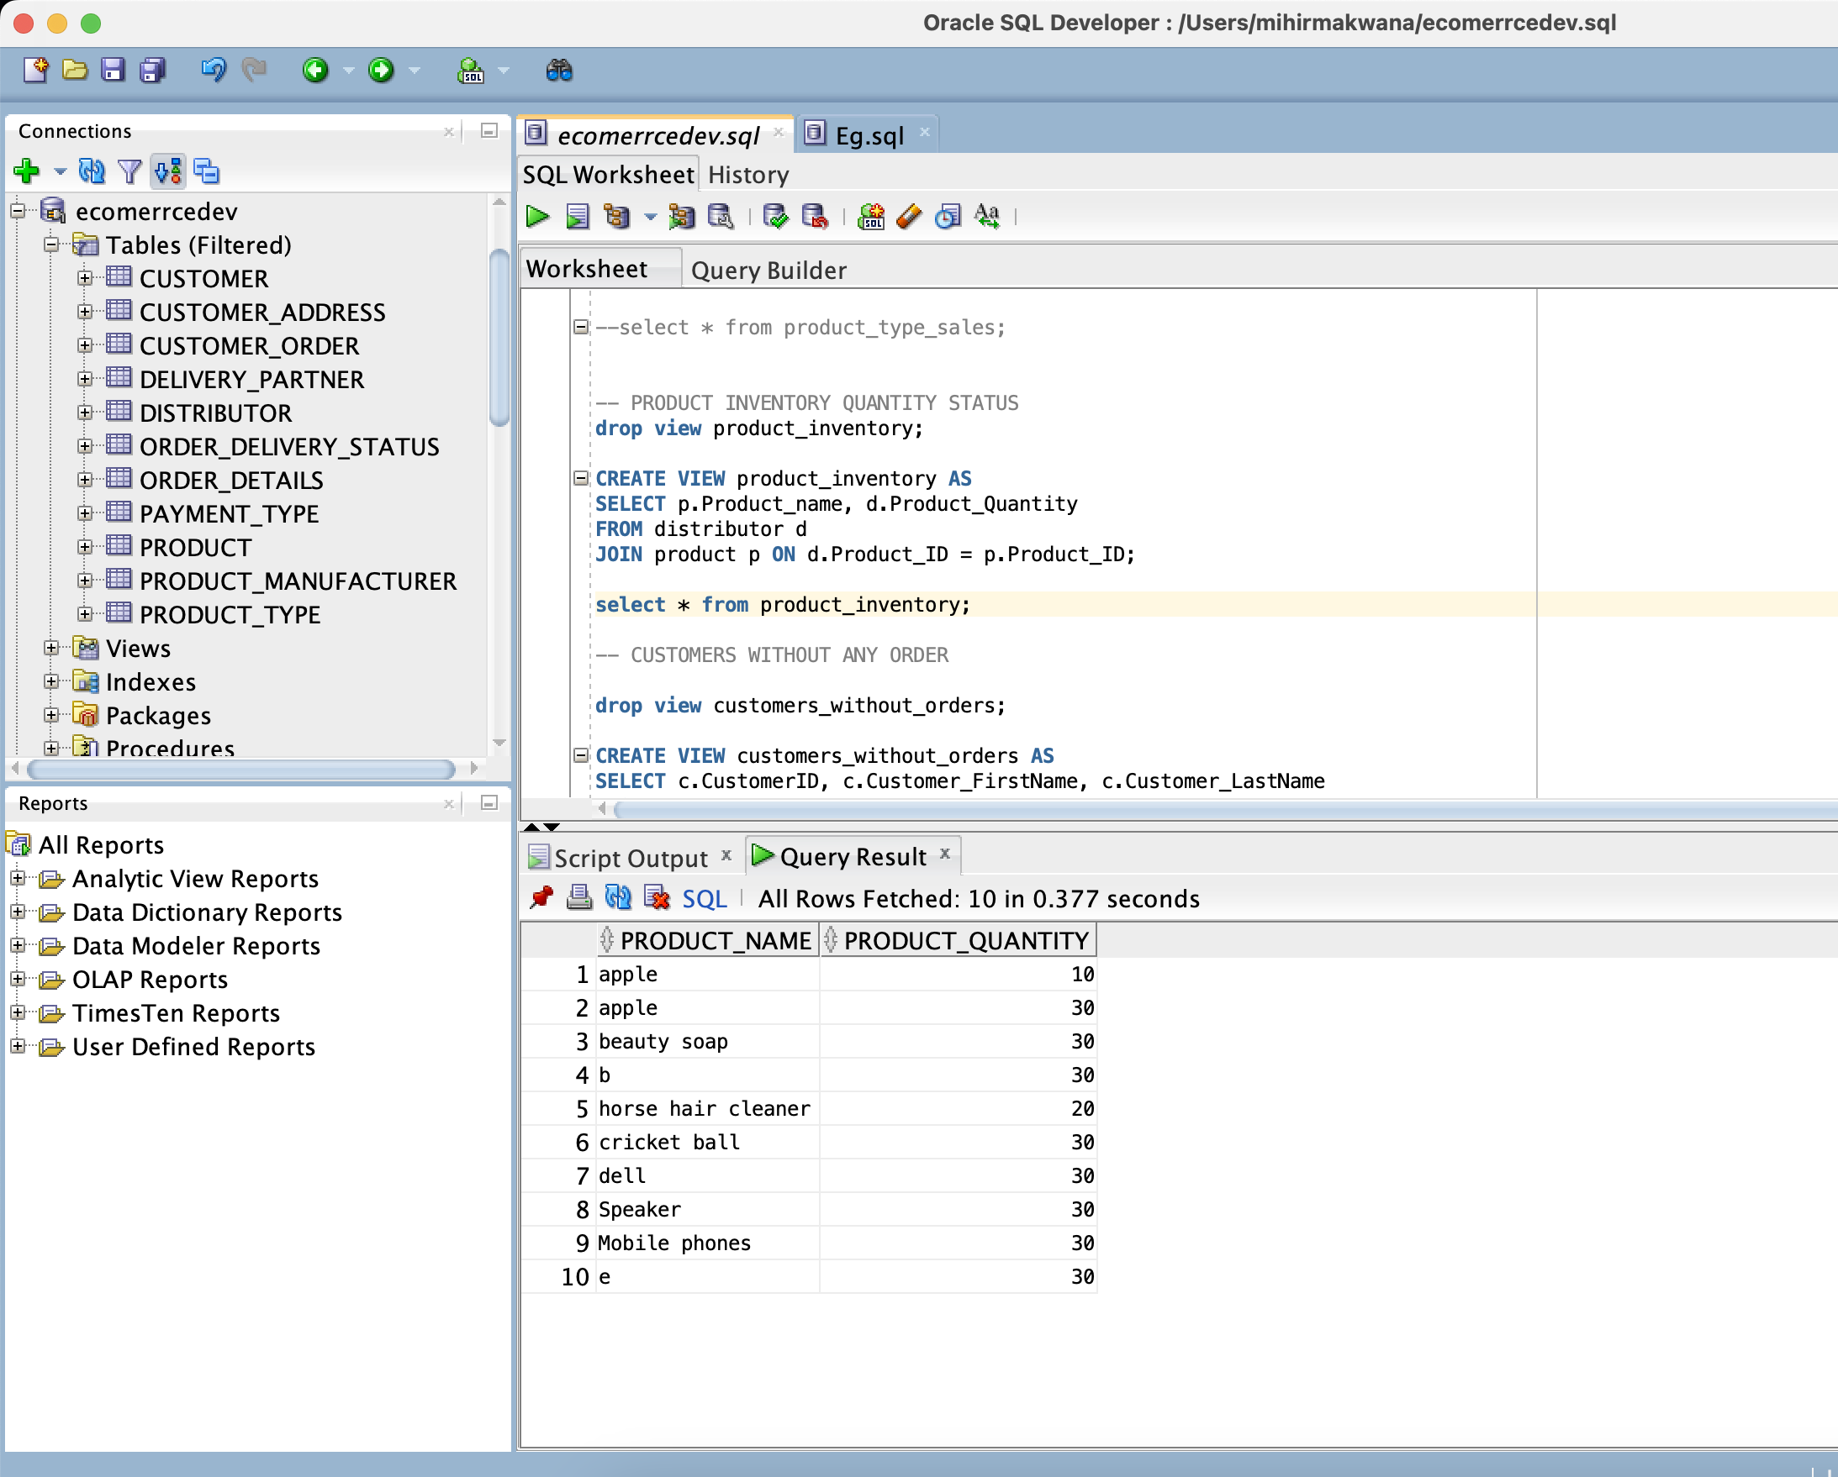

1. Customer Without Any Orders:

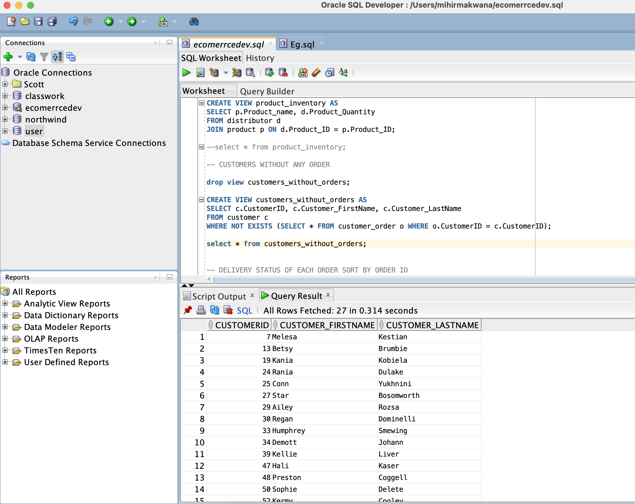

1. DELIVERY STATUS OF EACH ORDER SORT BY ORDER ID

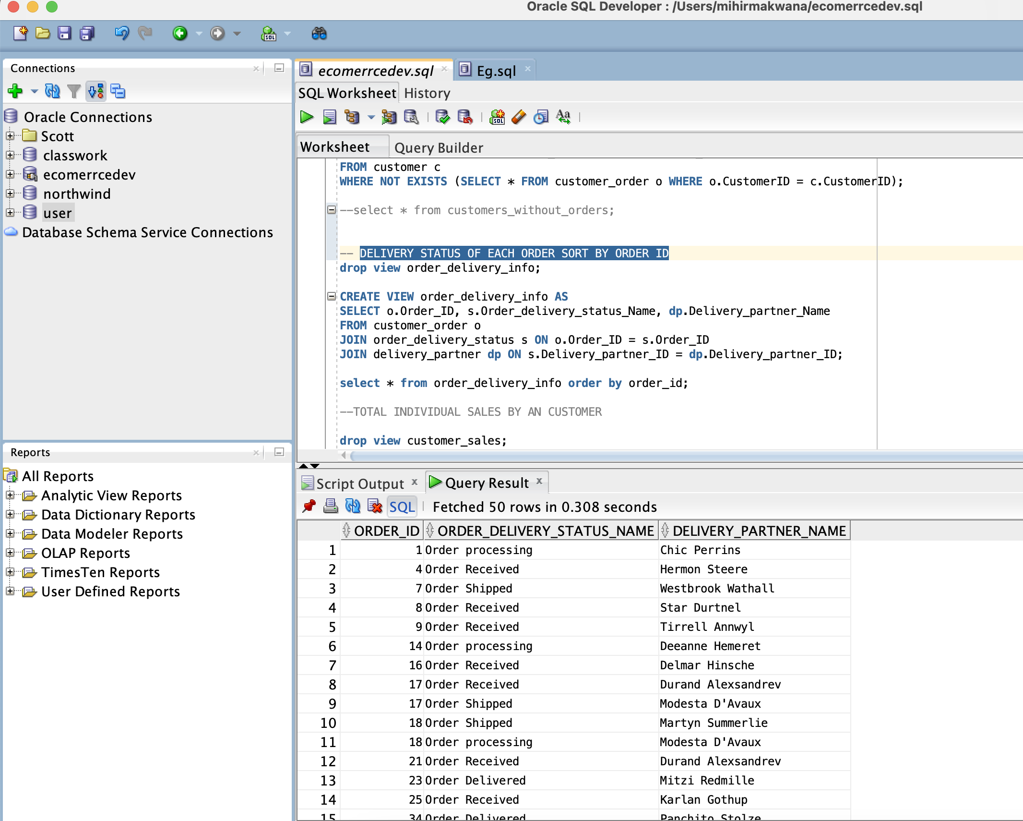

1. TOTAL INDIVIDUAL SALES BY AN CUSTOMER

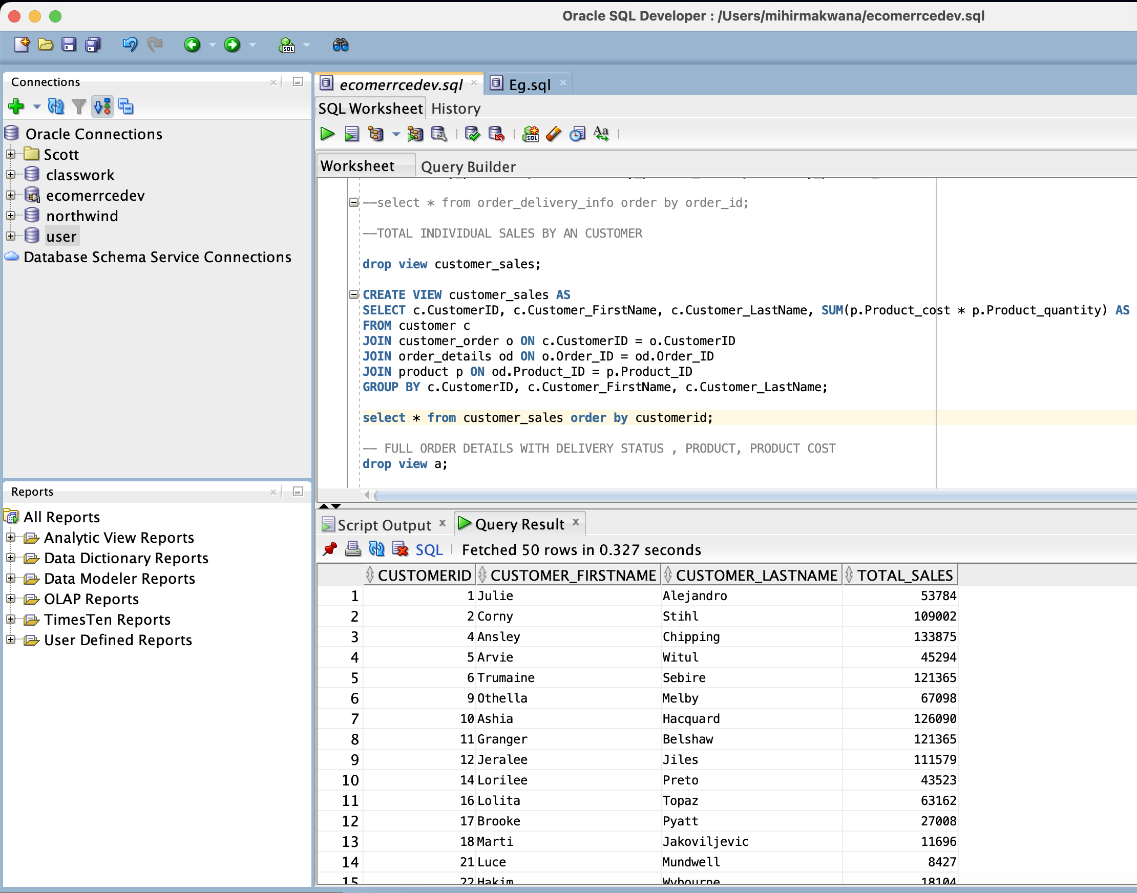

1. FULL ORDER DETAILS WITH DELIVERY STATUS , PRODUCT, PRODUCT COST

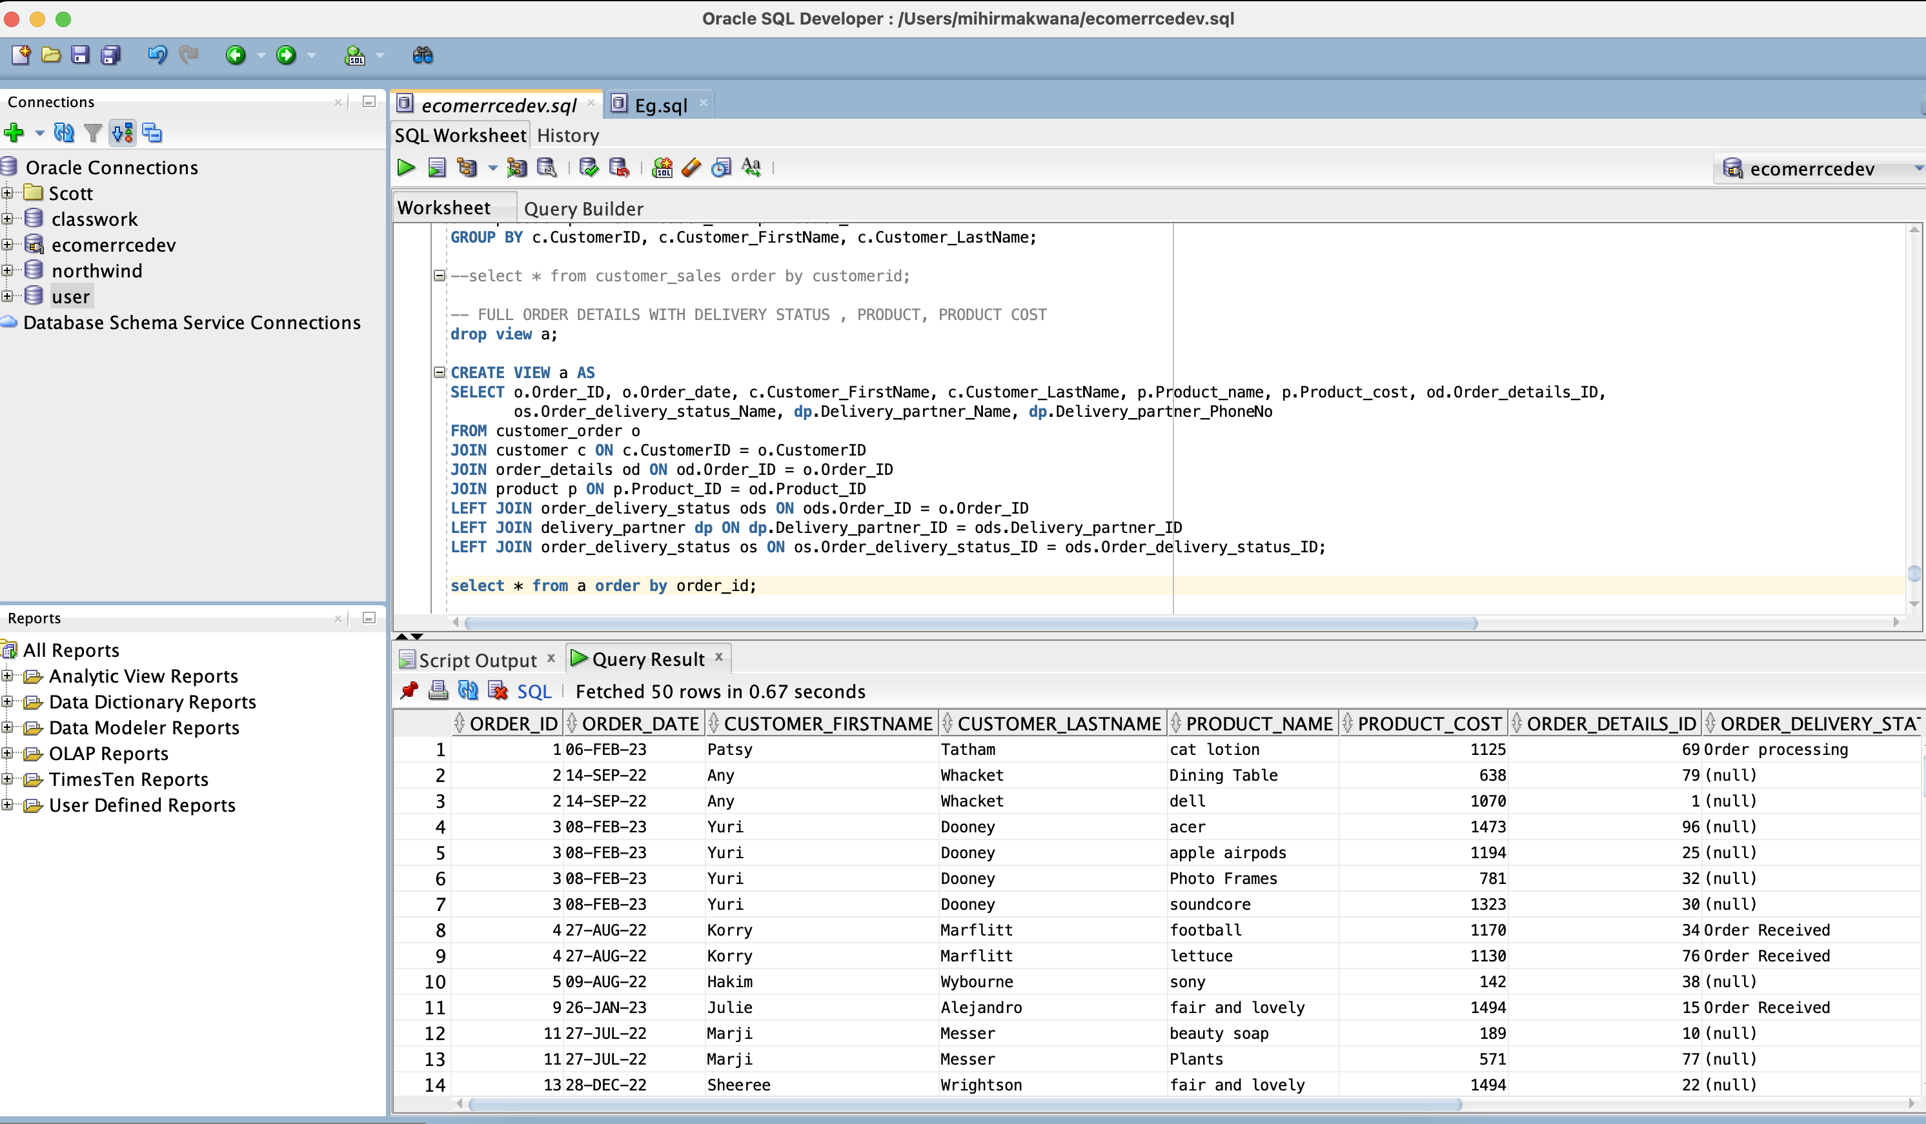

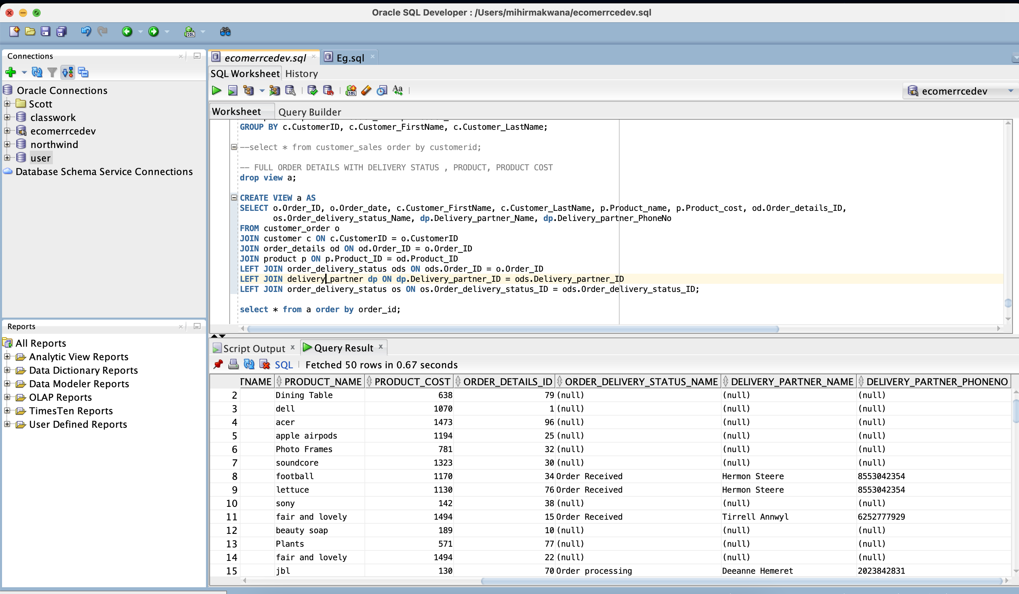

1. MONTHLY SALES

